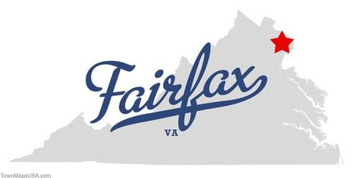
2018 Annual Meeting

Fairfax, Virginia
April 18-20, 2018

Call for Presentation Proposals
Deadline for submission: December 15, 2017

Go Alliance’s annual meeting connects professionals from national organizations and SREB states who work in the fields of college access and success, including staff from state education agencies, college access programs, and community-based organizations. The meeting highlights effective practice, current research, and resources to help programs improve their outreach to students who would be the first in their family to enroll in postsecondary education. Sessions highlight the latest developments in college access policy, support programs, partnerships, and social marketing campaign efforts. National experts lead hands-on sessions on topics relevant to member states.

Go Alliance seeks successful proposals for presentations on recent research findings or best practices on topics related to: access to postsecondary education for underserved students; postsecondary support and success programs for underserved students; or college access marketing campaigns. Suggested topics might include, for example:
- college access marketing campaigns
- postsecondary success programs
- student support programs (such as College Application Week, FAFSA support, postsecondary completion support programs, etc.)
- Proposals on better understanding and supporting particular target audiences, such as low-income students; rural students; adult learners; veterans and military connected students; Hispanic students; African American males; etc.
- Use of social psychology or behavioral economics in college access outreach/support (such as texting campaigns and behavioral nudges)
- Forming and sustaining successful partnerships

If your organization has developed a new or innovative program, and you are willing to discuss it, please complete a proposal. In particular, SREB seeks presentations that include data that can demonstrate a program’s effectiveness. In some cases, if proposals are similar topics, you might be asked to join a panel with other presenters, and panel members will have lead time to coordinate their presentations. You will be notified by January 12 if your presentation has been selected.

Instructions: Completing the Call for Presentation Proposals Submission Form
Compose and submit presentation proposals in the following manner:
- Complete one application for each presentation you are proposing.
- Fill out the contact information.
- Provide a summary of your proposal (limit: one-page)
- Email the submission form to aliceanne.bailey@sreb.org by December 15, 2017.

Call for Presentation Proposals Submission Form
- Program Title

- Session Presenter (s)
If you are submitting a proposal with other colleagues, please list one person as the primary contact.

First Name: Last Name:
Title:
Organization/Institution:
Telephone: Email:
Names and titles of additional presenters:
- Presentation Summary
Please describe your presentation (one page maximum). Use an additional sheet as needed.

- Audiovisual Needs
Please list any audio-visual resources you will require as part of your presentation other than a projector and screen.

Submit to aliceanne.bailey@sreb.org December 15, 2017.

