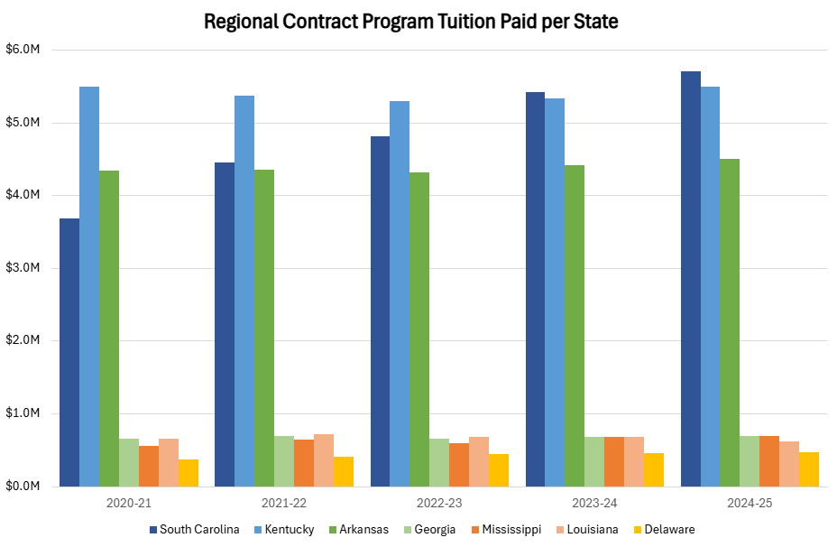\* pending Spring 2025 payment from SC to Tuskegee as of 4.16.25