 | This page is best viewed with a tables capable browser.  Version for the tables impaired.  For more AIMS Activities visit our home page.

Materials  - 7 sheets of brightly-colored tissue paper - 20" X 30"  - glue stick or white glue  - scissors  - transparent tape  Procedure  Step One: Fold in half (width-wise) two (2) sheets of tissue paper, one on top of the other, and cut along the fold.  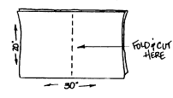  Step Two: Fold these four pieces in half.  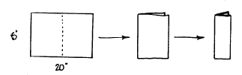  Open, and crease a diagonal from the outer lower corner to the upper opposite corner --repeat. Cut along the diagonals to produce four (4) trapezoids.  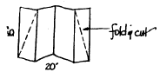 | 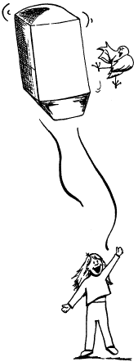
Step Three: Glue each trapezoid to one whole sheet of tissue, matching the longer base of each trapezoid to the shorter side of the whole tissue paper piece. Use approximately a one-inch seam.
Step Four: Assemble the four panels to form the four sides of your balloon.
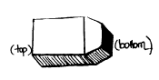
Step Five: The one (1) remaining piece becomes the top. Fold sheet diagonally to form a square. Cut off bottom rectangle. Glue square to top of balloon.
