Click here to go back to the normal view!

How Hot Air Balloons Work
by Tom Harris
If you actually need to get somewhere, a hot air balloon is a fairly impractical vehicle.You can't really steer it, and it only travels as fast as the wind blows. But if you simply want to enjoy the experience of flying, there's nothing quite like it. Many people describe flying in a hot air balloon as one of the most serene, enjoyable activities they've ever experienced.

Special thanks to CargoLifter for all their assistance with this article.
Hot air balloons are also an ingenious application of basic scientific principles. In this edition of How Stuff Works, we'll see what makes these balloons rise up in the air, and we'll also find out how the balloon's design lets the pilot control altitude and vertical speed. You'll be amazed by the beautiful simplicity of these early flying machines!
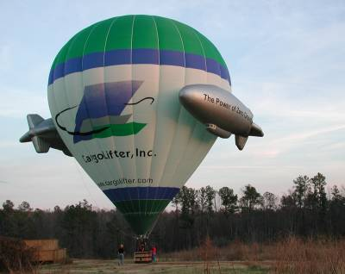
A four-passenger CargoLifter hot air balloon
Balloon Design
Hot air balloons are based on a very basic scientific principle: warmer air rises in cooler air. Essentially, hot air is lighter than cool air, because it has less mass per unit of volume. A cubic foot of air weighs roughly 28 grams (about an ounce). If you heat that air by 100 degrees F, it weighs about 7 grams less. Therefore, each cubic foot of air contained in a hot air balloon can lift about 7 grams. That's not much, and this is why hot air balloons are so huge -- to lift 1,000 pounds, you need about 65,000 cubic feet of hot air! To find out exactly how this works, skip to Air Pressure + Gravity = Buoyancy.
To keep the balloon rising, you need a way to reheat the air. Hot air balloons do this with a burner positioned under an open balloon envelope. As the air in the balloon cools, the pilot can reheat it by firing the burner.
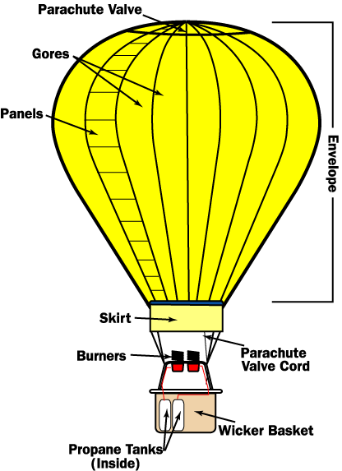
A hot air balloon has three essential parts: the burner, which heats the air; the balloon envelope, which holds the air; and the basket, which carries the passengers.
Modern hot air balloons heat the air by burning propane, the same substance commonly used in outdoor cooking grills. The propane is stored in compressed liquid form, in lightweight cylinders positioned in the balloon basket. The intake hose runs down to the bottom of the cylinder, so it can draw the liquid out.
Because the propane is highly compressed in the cylinders, it flows quickly through the hoses to the heating coil. The heating coil is simply a length of steel tubing arranged in a coil around the burner. When the balloonist starts up the burner, the propane flows out in liquid form and is ignited by a pilot light. As the flame burns, it heats up the metal in the surrounding tubing. When the tubing becomes hot, it heats the propane flowing through it. This changes the propane from a liquid to a gas, before it is ignited. This gas makes for a more powerful flame and more efficient fuel consumption.
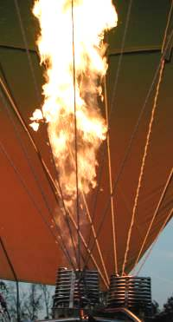
The burner flame heats the air in the balloon envelope.
In most modern hot air balloons, the envelope is constructed from long nylon gores, reinforced with sewn-in webbing. The gores, which extend from the base of the envelope to the crown, are made up of a number of smaller panels. Nylon works very well in balloons because it is lightweight, but it is also fairly sturdy and has a high melting temperature. The skirt, the nylon at the base of the envelope, is coated with special fire-resistant material, to keep the flame from igniting the balloon.
The hot air won't escape from the hole at the bottom of the envelope because buoyancy keeps it moving up. If the pilot continually fires the fuel jets, the balloon will continue to rise. There is an upper altitude limit, however, since eventually the air becomes so thin that the buoyant force is too weak to lift the balloon. The buoyant force is equal to the weight of air displaced by the balloon, so a larger balloon envelope will generally have a higher upper altitude limit than a smaller balloon.
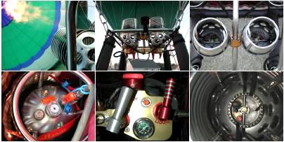
Click on the burner components to see a high-resolution picture.

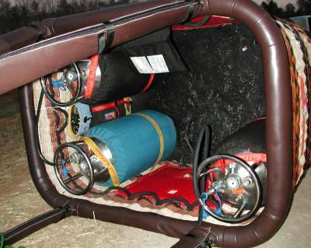
The basket holds the passengers, propane tanks and navigation equipment.
Most hot air balloons use a wicker basket for the passenger compartment. Wicker works very well because it is sturdy, flexible and relatively lightweight. The flexibility helps with balloon landings: In a basket made of more rigid material, passengers would feel the brunt of the impact force. Wicker material flexes a little, absorbing some of the energy.
Piloting
Piloting a balloon takes skill, but the controls are actually very simple. To lift the balloon, the pilot moves a control that opens up the propane valve. This lever works just like the knobs on a gas grill or stove: As you turn it, the flow of gas increases, so the flame grows in size. The pilot can increase the vertical speed by blasting a larger flame to heat the air more rapidly.
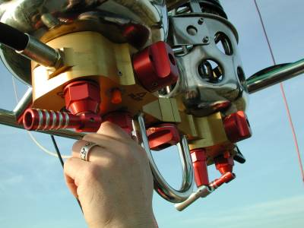
To blast the burner, the pilot opens the propane valve.
Additionally, many hot air balloons have a control that opens a second propane valve. This valve sends propane through a hose that bypasses the heating coils. This lets the pilot burn liquid propane, instead of propane in gas form. Burning liquid propane produces a less efficient, weaker flame, but is much quieter than burning gas. Pilots often use this second valve over livestock farms, to keep from scaring the animals.
Hot air balloons also have a cord to open the parachute valve at the top of the envelope. When the pilot pulls the attached cord, some hot air can escape from the envelope, decreasing the inner air temperature. This causes the balloon to slow its ascent. If the pilot keeps the valve open long enough, the balloon will sink.
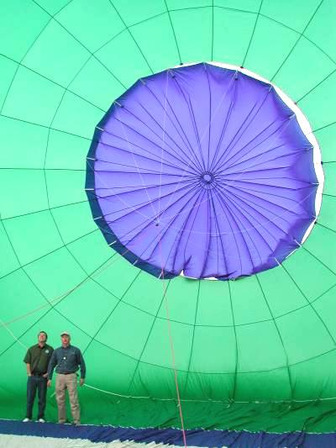
The parachute valve, from the inside of the balloon. A Kevlar cord runs from the valve at the top of the balloon, down to the basket, through the center of the envelope.
Essentially, these are the only controls -- heat to make the balloon rise and venting to make it sink. This raises an interesting question: If pilots can only move hot air balloons up and down, how do they get the balloon from place to place? As it turns out, pilots can maneuver horizontally by changing their vertical position, because wind blows in different directions at different altitudes. To move in a particular direction, a pilot ascends and descends to the appropriate level, and rides with the wind. Since wind speed generally increases as you get higher in the atmosphere, pilots can also control horizontal speed by changing altitude.
To maneuver the balloon horizontally, the pilot ascends or descends in altitude, catching different wind currents.
Of course, even the most experienced pilot doesn't have complete control over the balloon's flight path. Usually, wind conditions give the pilot very few options. Consequently, you can't really pilot a hot air balloon along an exact course. And it's very rare that you would be able to pilot the balloon back to your starting point. So, unlike flying an airplane, hot air balloon piloting is largely improvised, moment to moment. For this reason, some members of a hot air balloon crew have to stay on the ground, following the balloon by car to see where it lands. Then, they can be there to collect the passengers and equipment.
Launching and Landing
A lot of the work in hot air ballooning comes at the beginning and the end of the flight, when the crew inflates and deflates the balloon. For the spectator, this is a much more spectacular show than the actual balloon flight.
Once the crew has found a suitable launching point, they attach the burner system to the basket. Then they attach the balloon envelope and begin laying it out on the ground.
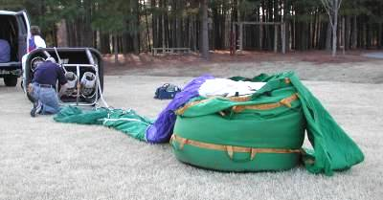
Once the envelope is laid out, the crew begins inflating it, using a powerful fan at the base of the envelope.
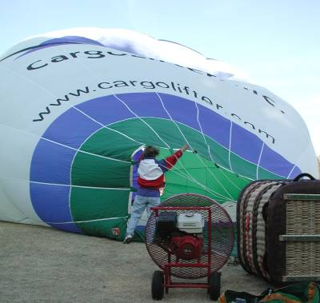
When there is enough air in the balloon, the crew blasts the burner flame into the envelope mouth. This heats the air, building pressure until the balloon inflates all the way and starts to lift off the ground.
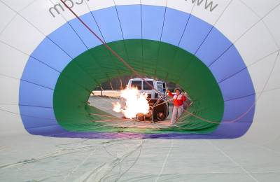
The ground crew members hold the basket down until the launch crew is on board. The balloon basket is also attached to the ground crew vehicle until the last minute, so the balloon won't be blown away before it is ready to launch. When everything is set, the ground crew releases the balloon and the pilot fires a steady flame from the burner. As the air heats up, the balloon lifts right off the ground.
Amazingly, this entire process only takes 10 or 15 minutes! The landing process, combined with deflating and re-packing the balloon envelope, takes a while longer.
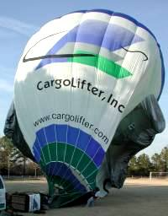
When the pilot is ready to land, he or she discusses possible landing sites with the ground crew (via an onboard radio). They need to find a wide open space, where there are no power lines and plenty of room to lay out the balloon. As soon as the balloon is in the air, the pilot is constantly looking for suitable landing sites, in case there is an emergency.
The balloon landing can be a little rough, but an experienced pilot will bump along the ground to stop the balloon gradually, minimizing the impact. If the ground crew has made it to the landing site, they will hold the basket down once it has landed. If the balloon isn't in a good position, the crew pulls it along the ground to a better spot.
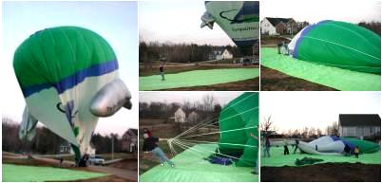
Click on the images for a high-resolution picture
The ground crew sets out a ground tarp, to protect the balloon from wear and tear. Then the pilot opens the parachute valve all the way, so the air can escape out the top of the balloon. The ground crew grabs a cord attached to the top of the balloon, and pulls the envelope over onto the tarp.
Once the balloon envelope is down on the ground, the crew begins pushing the air out. When the balloon is flattened, the crew packs it into a stuff sack. This whole process is a lot like packing up a giant sleeping bag.
Wind and Weather
Before launching, pilots will call a weather service to find out about climate and wind conditions in an area. Cautious pilots only fly when the weather is close to ideal -- when skies are clear and wind conditions are normal. Storms are extremely hazardous for hot air balloons, because of the danger of a lightning strike. Even rain is a problem, because it decreases visibility and damages the balloon material (of course, it's not much fun to fly around in wet weather anyway). And while you need a nice wind current to have a good flight, very strong winds could easily wreck the balloon.
Pilots also call the weather service to get a rough idea of which way the balloon will travel, and how they should maneuver once they're in the air. Additionally, a pilot might send up a piball (short for pilot balloon). A piball is just a balloon filled with helium that the pilot releases to see the exact direction of the wind at a prospective launch site. If it looks like the wind would take the balloon into prohibited air space, the crew needs to find a new launch spot.
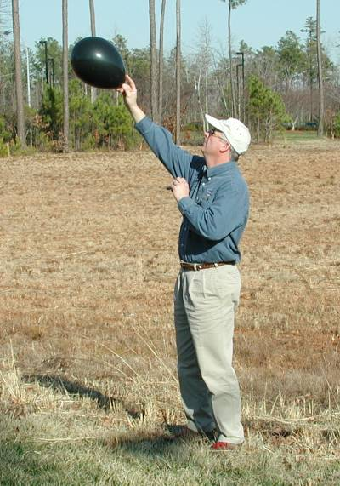
The pilot releases a helium-filled piball to
see which way the wind is blowing.
In the air, the pilot will use an onboard altimeter, variometer and their own observations to find the right altitude. Reaching the right altitude is pretty tricky because there is at least a 30-second delay between blasting the burners and the balloon actually lifting. Balloon pilots have to operate the appropriate controls just a little bit before they want to rise, and shut them off a little bit before they want to stop rising. Inexperienced pilots often overshoot, rising too high before leveling off. Controlled operation comes only with many hours of ballooning experience.
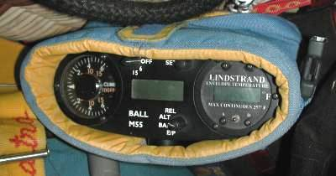
The pilot carries several instruments onboard the balloon.
Air Pressure + Gravity = Buoyancy
Now that we've seen how a hot air balloon flies through the air, let's look at the forces that make this possible. As it turns out, hot air balloons are a remarkable demonstration of some of the most fundamental forces on earth.
One amazing thing about living on earth is that we are constantly walking around in a high-pressure fluid -- a substance with mass and no shape. The air around us is composed of several different elements in a gaseous state. In this gas, the atoms and molecules of the elements fly around freely, bumping into each other and everything else. As these particles collide against an object, each of them pushes with a tiny amount of energy. Because there are so many particles in the air, this energy adds up to a considerable pressure level (at sea level, about 14.7 pounds of pressure per square inch (psi), or 1 kg per square centimeter (kg/cm²!).
The force of air pressure depends on two things:
- The rate of particle collision -- if more particles collide in a period of time, then more energy is transferred to an object.
- The force of the impact -- if the particles hit with greater force, more energy is transferred to an object.
These factors are determined by how many air particles there are in an area and how fast they are moving. If there are more particles, or if they are travelling more quickly, there will be more collisions, and so greater pressure. Increasing particle speed also increases the force of the particle's impact.
Most of the time we don't notice air pressure because there is air all around us. All things being equal, air particles will disperse evenly in an area so that there is equal air density at every point. Without any other forces at work, this translates to the same air pressure at all points. We aren't pushed around by this pressure because the forces on all sides of us balance one another out. For example, 14.7 psi is certainly enough to knock over a chair, or crush it from the top, but because the air applies roughly the same pressure from the right, left, top, bottom and all other angles, every force on the chair is balanced by an equal force going in the opposite direction. The chair doesn't feel substantially greater pressure from any particular angle.
So, with no other forces at work, everything would be completely balanced in a mass of air, with equal pressure from all sides. But on Earth, there are other forces to consider, chiefly gravity. While air particles are extremely small, they do have mass, and so they are pulled toward the Earth. At any particular level of the Earth's atmosphere, this pull is very slight -- the air particles seem to move in straight lines, without noticeably falling toward the ground. So, pressure is fairly balanced on the small scale. Overall, however, gravity pulls particles down, which causes a gradual increase in pressure as you move toward the earth's surface.
It works like this: All air particles in the atmosphere are drawn by the downward force of gravity. But the pressure in the air creates an upward force working opposite gravity's pull. Air density builds to whatever level balances the force of gravity, because at this point gravity isn't strong enough to pull down a greater number of particles.
This pressure level is highest right at the surface of the Earth because the air at this level is supporting the weight of all the air above it -- more weight above means a greater downward gravitational force. As you move up through levels of the atmosphere, the air has less air mass above it, and so the balancing pressure decreases. This is why pressure drops as you rise in altitude.
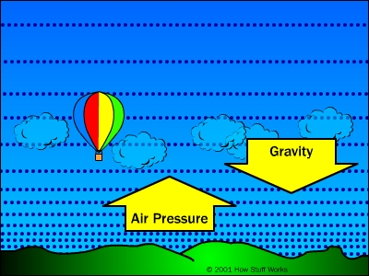
This difference in air pressure causes an upward buoyant force in the air all around us. Essentially, the air pressure is greater below things than it is above things, so air pushes up more than it pushes down. But this buoyant force is weak compared to the force of gravity -- it is only as strong as the weight of the air displaced by an object. Obviously, most any solid object is going to be heavier than the air it displaces, so buoyant force doesn't move it at all. The buoyant force can only move things that are lighter than the air around them.
In the next section, we'll see how hot air balloons take advantage of this basic principle.
Lighter than Air
In the last section, we saw that the atmosphere's buoyant force will only lift with a force equal to the weight of air the object displaces. So, for buoyancy to push something up in the air, the thing has to be lighter than an equal volume of the air around it.
The most obvious thing that is lighter than air is nothing at all. A vacuum can have volume but does not have mass, and so, it would seem, a balloon with a vacuum inside should be lifted by the buoyancy of the air around it. This doesn't work, however, because of the force of surrounding air pressure. Air pressure doesn't crush an inflated balloon, because the air inside the balloon pushes out with the same force as the outside air pushing in. A vacuum, on the other hand, doesn't have any outward pressure, since it has no particles bouncing against anything. Without equal pressure balancing it out, the outside air pressure will easily crush the balloon. And any container strong enough to hold up to the air pressure at the earth's surface will be much too heavy to be lifted by the buoyant force.
Another option would be to fill the balloon with air that is less dense than the surrounding air. Because the air in the balloon has less mass per unit of volume than the air in the atmosphere, it would be lighter than the air it was displacing, so the buoyant force would lift the balloon up. But again, fewer air particles per volume means lower air pressure, so the surrounding air pressure would squeeze the balloon until the air density inside was equal to the air density outside.
All of this is assuming that the air in the balloon and the air outside the balloon exist under exactly the same conditions. If we change the conditions of the air inside the balloon, we can decrease density, while keeping air pressure the same. As we saw in the last section, the force of air pressure on an object depends on how often air particles collide with that object, as well as the force of each collision. We saw that we can increase overall pressure in two ways:
- Increase the number of air particles so there is a greater number of particle impacts over a given surface area.
- Increase the speed of the particles so that the particles hit an area more often and each particle collides with greater force.
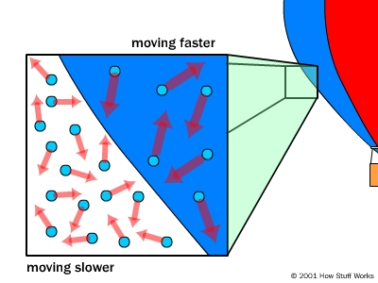
There are fewer air particles per unit of volume inside the balloon, but because those particles are moving faster, the inside and outside air pressure are the same.
So, to lower air density in a balloon without losing air pressure, you simply need to increase the speed of the air particles. You can do this very easily by heating the air. The air particles absorb the heat energy and become more excited. This makes them move faster, which means they collide with a surface more often, and with greater force.
For this reason, hot air exerts greater air pressure per particle than cold air, so you don't need as many air particles to build to the same pressure level. So a hot air balloon rises because it is filled with hot, less dense air and is surrounded by colder, more dense air.
Ballooning History
The basic idea behind hot air balloons has been around for a long time. Archemedes, one of the greatest mathematicians in Ancient Greece, figured out the principle of buoyancy more than 2,000 years ago, and may have conceived of flying machines lifted by the force. In the 13th century, the English scientist Roger Bacon and the German philosopher Albertus Magnus both proposed hypothetical flying machines based on the principle.
But nothing really got off the ground until the summer of 1783, when the Montgolfier brothers sent a sheep, a duck and a chicken on an eight-minute flight over France. The two brothers, Joseph and Etienne, worked for their family's prestigious paper company. As a side project, they began experimenting with paper vessels elevated by heated air. Over the course of a couple years, they developed a hot air balloon very similar in design to the ones used today. But instead of using propane, they powered their model by burning straw, manure and other material in an attached fire pit.
Blowin' in the Wind
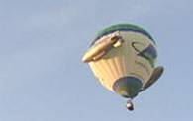
So, what's it like to ride in a hot air balloon? It is a remarkably serene, peaceful experience. Since the balloon moves with the wind, you don't feel any breeze at all. Without the rushing winds you normally associate with high altitudes, the experience of flying seems very safe and calming -- you simply lift off the ground and move with the air in the atmosphere!
The sheep, duck and chicken became the first balloon passengers on Sept. 19, 1783, in the Montgolfiers' first demonstration flight for King Louis XVI. They all survived the trip, giving the King some assurance that human beings could breath the atmosphere at the higher elevation. Two months later, the Marquis Francois d'Arlandes, a major in the infantry, and Pilatre de Rozier, a physics professor, became the first human beings to fly.
Other hot air balloon designs and ambitious flights followed, but by 1800, the hot air balloon had been largely overshadowed by gas balloons. One factor in this popularity decline was the death of Pilatre de Rozier in an attempted flight over the English Channel. The new balloon he built for the flight included a smaller hydrogen balloon in addition to the hot air balloon envelope. The fire ignited the hydrogen early in the flight, and the entire balloon burst into flames.
But the main reason hot air balloons fell out of fashion was that new gas balloon dirigible designs were superior in a number of ways -- chiefly, they had longer flight times and could be steered.
Another popular balloon type was the smoke balloon. These balloons were lifted by a fire on the ground, and did not have any attached heat source. They simply shot up in the air, and then sank back to the ground. Their main use was as an attraction at travelling fairs in the United States in the late 1800s and early 1900s. The balloonist would put on a parachute and attach himself to a canvas balloon. Then, several assistants would hold the balloon over a fire pit, getting the air hotter and hotter, and so increasing the upward force. When the force was great enough -- and if the balloon hadn't caught on fire -- the assistants would let go and the balloonist would be launched into the air. When the balloon reached its highest point, the balloonist would detach and parachute to the ground.
Since the 1960s, traditional hot air balloons have enjoyed a renaissance, due in part to a man named Ed Yost and his company, Raven Industries. Yost and his partners founded Raven Industries in 1956 to design and build hot air balloons for the United States Navy's Office of Naval Research (ONR). The ONR wanted the balloons for short-range transportation of small loads. Yost and his team took the basic concept of the Montgolfier brothers' balloon and expanded it, adding the propane burner system, new envelope material, a new inflation system and many important safety features.
They also came up with the modern, light-bulb-style envelope shape. Yost first designed large, spherical balloons. These balloons worked well, but had an odd inflation pattern: When the air was heated, the top of the balloon filled up, but the bottom stayed under-inflated. For efficiency, Yost just got rid of the extra fabric at the bottom, developing the familiar "natural" balloon shape we see today.
By the early 1960s, the ONR had lost interest in hot air balloons, so Yost began selling his balloons as sporting equipment. Other companies soon sprang up, as more and more people got involved in ballooning. Over the years, designers have continued to modify hot air balloons, adding new materials and safety features, as well as developing creative envelope shapes. Some manufacturers have also increased basket size and load capacity, building balloons that hold up to 20 passengers!
But the basic design is still Yost's modified version of the Montgolfier brothers' original concept. This remarkable technology has enthralled people all over the world. Balloon tours are a multi-million dollar business, and balloon races and other events continue to attract crowds of spectators and participants. It's even become fashionable (among billionaires) to build high-tech balloons for trips around the world. It really says a lot about hot air balloons that they are still so popular, even in the age of jet planes, helicopters and space shuttles!
Lots More Information!
Related HowStuffWorks Articles
- How Force, Power, Torque & Energy Work
- How CargoLifter's Airship Will Work
- How Helium Balloons Work
- How Submarines Work
- How Tire Pressure Gauges Work
- How Airplanes Work
- How Helicopters Work
- How do pressurized airplane cabins work?
- Why is it colder at the top of a mountain than it is at sea level?
- How Flying Cars Will Work
More Great Links
- CNN.com: Balloonist completes around-the-world trek
- CargoLifter airships and hot air balloons
- The history of hot air balloons
- Another hot air balloon history
- Building Your Own Hot Air Balloon!
- NASA's Scientific Ballooning Program
- Hot Air Balloon Simulator
- BalloonZone: Hot Air Ballooning
- World Wide Web Balloon Pages
- eHotAirBallooning.com

 | Home | Store | Newsletter | Advertising | Privacy | Suggestions | Contact | About | Help
 | © 1998 - 2003 HowStuffWorks, Inc.

