How to replace and delete files

It’s an easy matter to add a new file to a post and delete the old one. The new file will be there when someone clicks on it from the post.

But that doesn’t completely exorcise the old file from the website – it’s likely lurking about as a file or archived post revision people might stumble onto by search. If there’s something really wrong with a document – an incorrect number or misspelled name – and the link to the file has already been shared, you might want to go to the trouble of hunting the old file down and killing it for good.

And this is some work.

Newer versions of uploaded files are always assigned a unique name and URL, e.g. a new version of annual-report.pdf will be renamed to annual-report-0.pdf, annual-report-1.pdf, etc. This is not true when you replace instead, correct?
Correct. The new file just slips into the place of the file being replaced, and it can retain the same name. You might want to change this to something like:
Note: Newer versions of uploaded files are usually assigned a unique name and URL, e.g. a new version of annual-report.pdf will be renamed to annual-report-0.pdf, annual-report-1.pdf, etc. The only exception to this is when a file is being replaced. In that case, the new file takes the place of the old file and the name can remain the same.

1. REPLACE the file

First, do not go into the post and delete the old file and upload the new one. Instead replace the file through the file management system.

Take a look at the URL of the file (not the post) you want to delete. The words after the last / will help you search for the file.
http://www.digitaldeployment.com/sites/main/files/file-attachments/regionalsancasestudy.pdf

Bottom left under COMMANDS, select Manage Content.
Click the Manage Files tab and enter the highlighted words name of the file from the URL in the Filter box.

Click Replace button to the right of the file you want to replace. (Click the filename first to be absolutely sure you select the right file.)

Click Select file… to browse for the replacement file and follow the prompts.
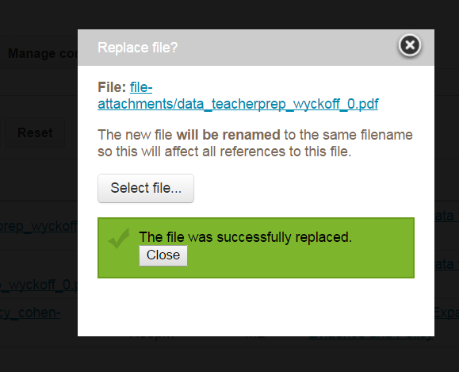

More on this from Digital Deployment > https://support.digitaldeployment.com/support/solutions/articles/4000023432-replacing-file-attachments
As a user, including this is a bit confusing. I wasn’t sure if I needed to open the link and follow the steps. Maybe a note along the lines of “FYI: Here’s the Digital Deployment article on the same process.”

The Search Index will probably update eventually on its own, but when you really want to make sure that the new file replaces the old file as quickly as possible, follow these steps too:

2. UPDATE the Search Index

Open the article with the replaced file > select Edit this article > without making any changes, click Save.

Search engines don’t “understand” that a change has been made to an article when a file is replaced, so they continue to display the previous version of the article. By “editing” this article, it triggers the search indexes to post the newer version of the article that has the new file.

None of the following steps are needed when replacing files since the new file will also replace the files in all previous versions.

2. Delete old post revisions that use the old file
Use the main site search to search for the error in the old file. If it still shows up, it’s most likely attached to a previous, archived revision of the post.

Go to Commands > Manage Content and click Manage Files tab on top.
Type the file name into the "Filter Files" field.

Click the post title and see that it's not being used in the current revision, you'll know that it's being used in a past revision, which has been archived and therefore still accessible through search.

To delete a file permanently from the site, you have to delete it from all post revisions (current and archived) (How do we do this? When I tried this after replacing the file, the archived revisions had the new file. So I deleted the old revisions.)

3. Delete the file from the server

Only system administrators can delete files.

Why is this important?
Once a file is uploaded to the site, it has its own URL on the Digital Deployment servers.
If you delete the file appearing on a post, it does not delete the file from the DD servers.
That URL still works until you delete the file under File Browser. Here’s how.

Improbably, File Browser is under My Account:

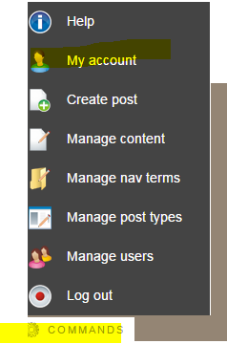

Click the File Browser tab.
Be sure navigation is exposed on the left. Pull the three dots to the right if they’re not.

Select file-attachments.

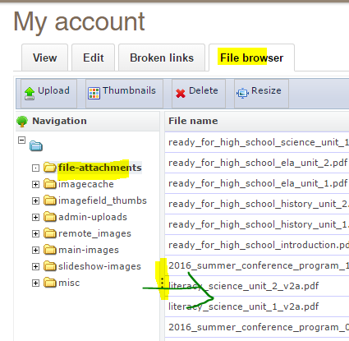

Here you can
a) sort files by date, or
b) CtrlF to search. The search operates on file name only, so you have to know part or all of the name of the file you’re looking for.

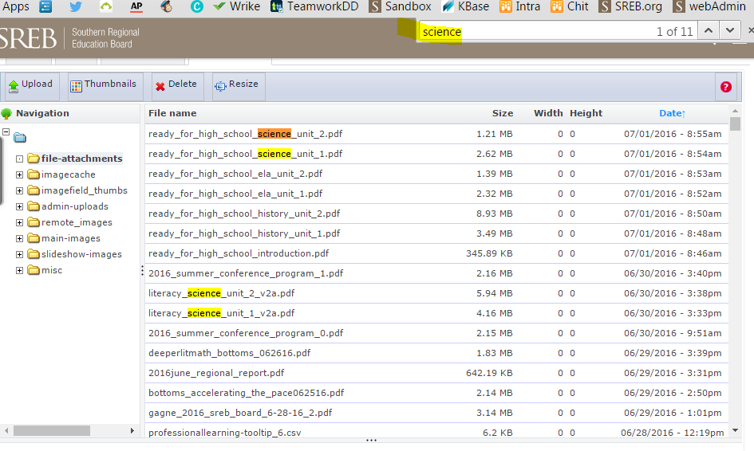

Seems to me when we did this before the file wouldn’t delete unless we had already deleted all the archived revisions that used it?

