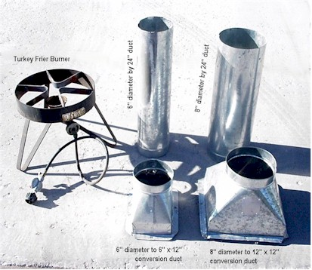 | 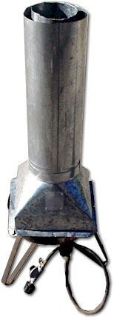
Tissue Paper Balloon - Burner
Parts List:
- Burner from Turkey Fryer
- 6" diameter by 24" duct
- 8" diameter by 24" duct
- 6" diameter to 6" by 10" conversion duct
- 8" diameter to 12" by 12" conversion duct.
Assembly instructions:
- Place the duct tubes into their corresponding conversion duct pieces.
- Place the 6" diameter duct assembly on the turkey fryer.
- Place the 8" diameter duct assembly over the 6" diameter duct assembly already on the turkey fryer. This results in an air space between the 6" diameter duct assembly and the 8" diameter duct assembly.
Assembly Animation.

